Комунальний заклад освіти
«Середня загальноосвітня школа № 42»
Дніпропетровської міської ради

Ток шоу
з англійської мови
для учнів 8 класу
до тижня англійської мови

«How do you do, Britain»

Дніпро 2016

Мета заходу:
Освітня: відпрацювати фонетичні навички; вчити розуміти іноземну мову в ігрових ситуаціях; проконтролювати мовні навички та вміння учнів; проконтролювати рівень засвоєння учнями даних тем.

Розвиваюча: розвивати вміння застосовувати вивчені лексичні одиниці та граматичні правила в конкретній обстановці; розвивати здогадку та вміння швидко орієнтуватися в умовах непідготовленого монологічного мовлення.

Виховна: прищеплювати цікавість до культури, історії, традицій англомовних країн; виховувати вміння працювати в колективі (команді).

Обладнання: заготовки з завданнями та варіантами відповідей на тестові завдання; 2 набори ігрових карток (див. додатки), Power point presentation, плакати

Склад команд: кожна з команд складається з семи учасників - шести гравців та капітана.

Час, необхідний для проведення вікторини: 45 хвилин

План проведення заходу

1. Організаційний момент.
2. Основна частина гри
2.1 Розминка. Бліцтурнір.
2.2 Конкурс „Literature”.
2.3 Конкурс на кращого знавця символіки англомовних країн.
2.4 Гра „The Pet Game”.
2.5 Конкурс капітанів “Go on!”.
2.6 Конкурс “Professions, professions …”
2.7 Конкурс “World of books”
3. Підведення підсумків вікторини, нагородження переможців.
Хід заходу
1. Організаційний момент.
а) привітання;
Dear Friends! We are very glad to see you here. Glad to meet you, dear boys and girls. Today we are having a competition, an English quiz and each of you will take part Today we will play.
Today we are going to have a kind of intellectual game between two teams. We hope it'll be rather interesting for you and you'll have a good time. So, be attentive, listen to all the questions and try to give, the right answers. We wish you good luck and hope for your active participation. And whatever team is the first, the main winner, of course, will be friendship. Yes, you'll have to work together to make the common decision and it's possible only when you are united, when you are real friends.

б) повідомлення правил гри;

в) представлення команд (коротке повідомлення про склад команди, її назву).

2. Основна частина гри.
2.1. Розминка.
Blitz Tournament
"What I know about Great Britain?"
1. Who sat at the head of the knight’s "round table"? (King Arthur).
2. The highest mountain in Britain. (Ben Nevis).
3. The home of the legendary monster in Scotland. (Loch Ness).
4. What is Rugby? (Sports game with an oval ball, a city in England.)
5. In playing the famous Wimbledon? (Tennis).
6. Which of London parks has "Speakers' Corner"? (Hyde Park.)
7. Why is the year of 1666 is so memorable for London? (Year of the Great Fire.)
8. A musical instrument, which is a leather bag with a pipe through which air is blown. (Bagpipe.)
9. Why does Irish coin show the harp? (This is the national instrument of Ireland).
10. Who gave the name to one part of the UK - England? (The tribes of Angles, in the V century).
11. Who was the first English king? (Alfred the Great).
12. Who and when invented penicillin? (The British scientist Alexander Fleming in 1929).
13. What is the name of the Tragic Queen of Scotland? (Mary Stuart).
14. Who is called Beefeater or meat eater? (40 men who guard the Tower. It is introduced by Henry III. They fed meat.)
15.What food does the traditional Christmas lunch include? (Roast turkey, Christmas pudding).
16. What is the floral symbol of Scotland. (Thistle.)
17. What date is April 23, 1564? (Shakespeare was born.)
18. What are the most popular pets UK. (Cats, dogs, horses).
19. Six servants that serve every person in Kipling. (Question: who, what, where, when, why, how).
20. Name at least four sports which were born in England. (Cricket, football, golf, rugby, racing, boxing).
2.2. Конкурс „Literature”
Find as many words in this word-search as you can. All of them refer to the topic “Literature” (додаток Б)
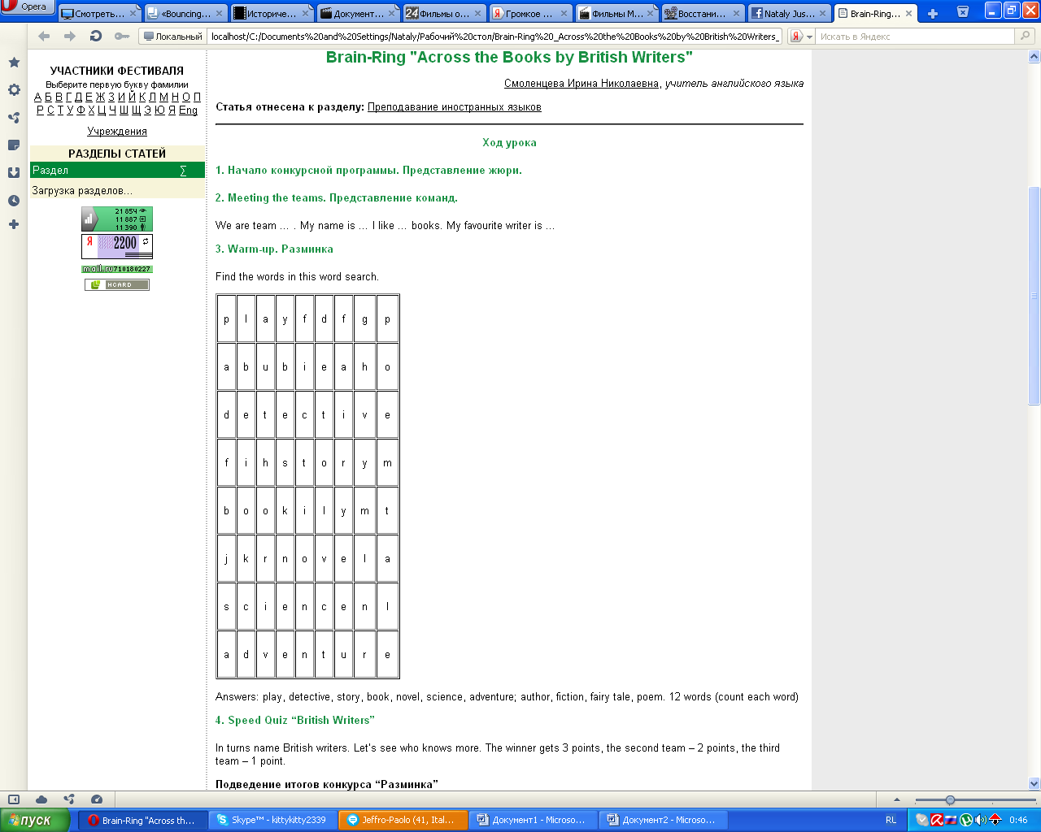

Answers: play, detective, story, book, novel, science, adventure; author, fiction, fairy tale, poem.

12 words (count each word, 1 point for any right one)

2.3. Конкурс на кращого знавця країнознавчого матеріалу
На магнітній дошці розміщено картки з символами різних англомовних країн, зображенням до дошки. Капітани команд по черзі обирають номер картки. Завдання команди – назвати країну, дати коротке повідомлення про неї англійською мовою. (додаток В)

2.4 The Pet Game
Choose a number of cards, read the sentence, say if it is true or not, change the sentence to make it true (додаток Г)
1  A mouse is a very large pet | 2  Cats drink lemonade | 3  Tortoises are more playful than dogs
4  A tortoise can run very fast | 5  A hamster eats eggs | 6  Birds sing at night
7  People take their cats for walks | 8  Cats can speak English | 9  Dogs can fly
10  Snakes play with dogs | 11  Horses eat meat | 12  Fish are noisy pets

2.5. Captains’ contest “Go on!”
It is called “Go on!” The task is to answer the questions at high speed. If you don’t know or don’t remember the answer, you should say “Go on!”, because your time is limited.

a) The questions to the first team
- What river does London stand on? (The Thames).
- What is the America’s symbol of Freedom? (The Statue of Liberty).
- What is “Penny Black”? (The stamp).
- How old is London? (2000 years old).
- Who is the head of the state in Great Britain? (A monarch).
- Whose portraits are printed on American dollars? (American presidents).
- What kind of weather is the most common in GB? (Rainy).
- At first Native Americans were called… (Indians).
- Name any national English game (football, cricket, rugby).
- What animal is the symbol of the English strength and power (lion)?

b) The questions to the second team
- Who was the first American president? (G. Washington).
- How many countries does the UK consist of? (4 countries).
- Where does the monarch of the UK live? (Buckingham Palace).
- What is the flag of the USA called? (“Stars and Stripes”).
- Who are “Beefeaters”? (The guards of the Tower).
- Who is the head of the state and government of the USA? (The President).
- What river is the capital of the USA situated on? (The Potomac).
- How many states are there in the USA? (50)
- When is the Thanksgiving Day celebrated? (On the fourth Thursday of November).
- What is the address of the White House? (1600, Pennsylvania Avenue).

2.6 Professions, professions…

Do you know these famous people and their professions? Teams answer in turn.

- Tchaikovsky was a … (composer)
- Charlie Chaplin was a … (actor)
- Lewis Carrol was a … (writer)
- Michelangelo was a … (artist)
- Archimedes was a … (scientist)
- Cleopatra was a … (Queen)
- George Washington was a … (President)
- The Beatles were … (singers)

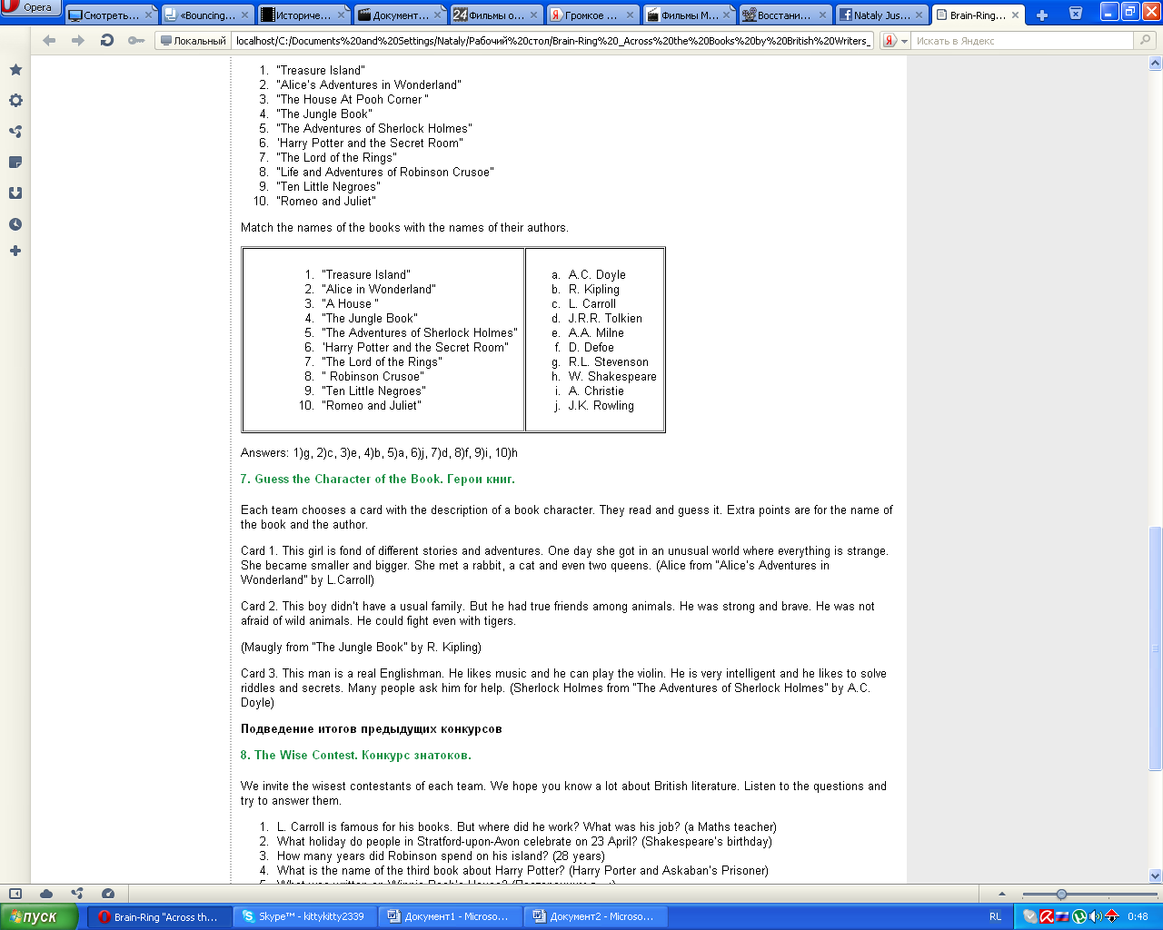
2.7 World of books
(Додаток Д)

3. Підведення підсумків вікторини, нагородження переможців
Журі підраховує загальну суму балів кожної команди. Ведучі відзначають найбільш активних учасників команд та вболівальників. Команда-переможниця отримує диплом І ступеня, інша команда – ІІ ступеня.

Д о д а т к и
Додаток А

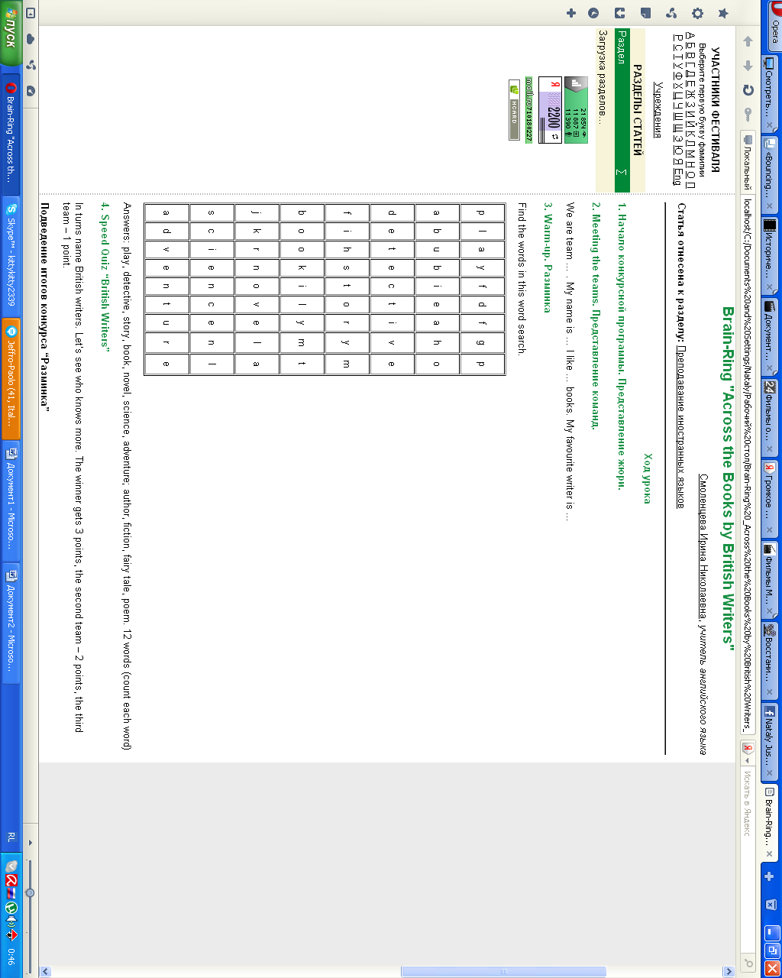
Додаток Б
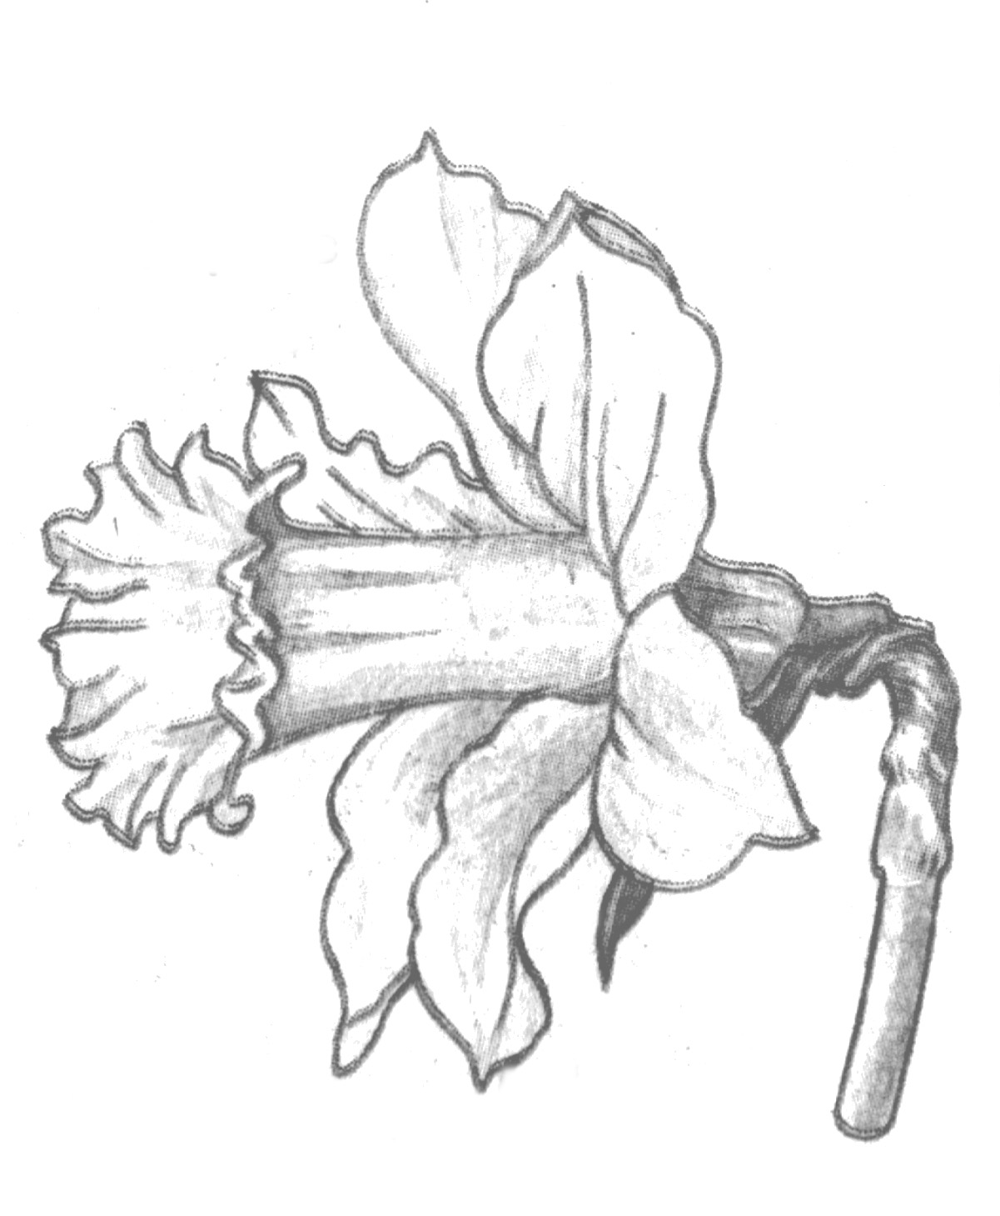

Додаток В

Додаток Г

1  A mouse is a very large pet | 2  Cats drink lemonade | 3  Tortoises are more playful than dogs
4  A tortoise can run very fast | 5  A hamster eats eggs | 6  Birds sing at night
7  People take their cats for walks | 8  Cats can speak English | 9  Dogs can fly
10  Snakes play with dogs | 11  Horses eat meat | 12  Fish are noisy pets

1  A mouse is a very large pet | 2  Cats drink lemonade | 3  Tortoises are more playful than dogs
4  A tortoise can run very fast | 5  A hamster eats eggs | 6  Birds sing at night
7  People take their cats for walks | 8  Cats can speak English | 9  Dogs can fly
10  Snakes play with dogs | 11  Horses eat meat | 12  Fish are noisy pets

1  A mouse is a very large pet | 2  Cats drink lemonade | 3  Tortoises are more playful than dogs
4  A tortoise can run very fast | 5  A hamster eats eggs | 6  Birds sing at night
7  People take their cats for walks | 8  Cats can speak English | 9  Dogs can fly
10  Snakes play with dogs | 11  Horses eat meat | 12  Fish are noisy pets
Додаток Д

