It is a clever African.
Its memory is long.
It likes living in the forest.
It’s very beautiful and strong.

It likes the leaves on tops of trees.
They‘re clean and very sweet.
It likes fresh grass.
It has got two strong large feet.

A very long nose.
It grows and grows.
It is huge and likes fun.
It is … AN ELEPHANT.
Zebra Riddles
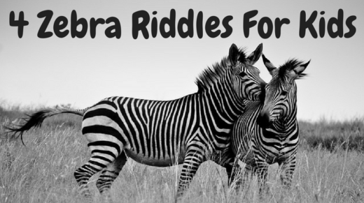
This is something black and white
But it’s not an old TV
It’s a type of animal
That starts with the letter Z
~
I am a type of animal
You might see on a safari
I’m covered in black and white stripes
I’m part of the horse family
~
This thing has black and white stripes
But it isn’t a barcode
It is something with four legs
But it’s not a slimy toad
~
What Am I?
I’m black and white but I’m not a newspaper
I have stripes but I’m not a prisoner uniform
I have a unique pattern but I’m not a barcode
I have four legs but I’m not a skunk
I’m part of the horse family but I’m not a donkey

Squirrel Riddles
August 13, 2015 By Stephen Pepper
We’re continuing with our theme of animal riddles today with four where the answer is ‘squirrel.’
These are therefore also perfect for using with some of our other themes, such as books, fall and nature.
The first three of these are rhyming riddles for kids; the word ‘squirrel’ completes the rhyme of the second one.
The collection is rounded off with one that asks What Am I? To use that final idea, read the first clue to your kids and ask them to guess the answer. As it says that it’s something that climbs trees, they might guess that you’re describing a monkey.
If they don’t guess that it’s a squirrel, read them the second clue and have them guess again. Keep doing this until your children either guess that you’ve been describing a squirrel or they run out of clues.
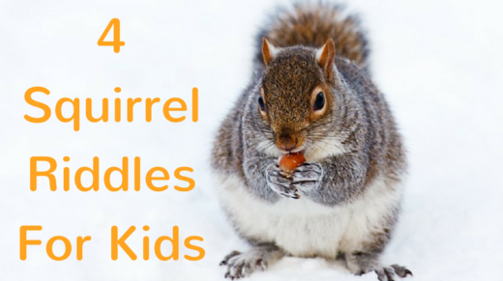
This is a type of animal
Of which Nutkin was a male
They climb trees and collect nuts
And they have a bushy tail
~
I am a type of rodent
You might see often in the fall
I run round gathering nuts
I climb trees – I’m a _ _ _ _ _ _ _ _
~
One in a book had the name Nutkin
Then there’s the friend of Bullwinkle
Scrat from the movie Ice Age was one
What are these types of animal?
~
What Am I?
I climb trees but I’m not a cat
I hibernate but I’m not a bear
I eat nuts but I’m not a bird
I’m a type of rodent but I’m not a rat
I have a bushy tail but I’m not a fox

Bear Riddles

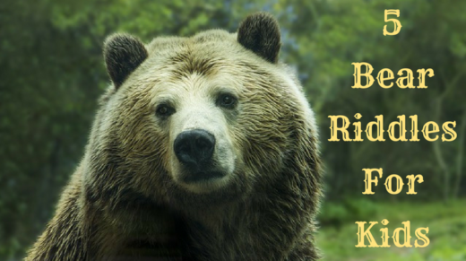
I am a type of mammal
Whose height and strength are very great
I have big paws and thick fur
And in dark caves I hibernate
~
What is this type of animal?
A cartoon had one called Yogi
Then there’s the well-known Paddington
And in The Muppets there’s Fozzie
~
If you see one when you’re camping
It might give you a big fright
They can be black, brown or grizzly
And pandas are black and white
~
What is this type of animal?
The Jungle Book had Baloo
Smokey warns you about fires
There’s also Winnie-The-Pooh
~
What Am I?
I’m one of the animals in The Muppets but I’m not a pig
I have large paws but I’m not a lion
I have fur but I’m not a cat
I sometimes live in caves but I’m not a bat
I hibernate but I’m not a squirrel

Horse Riddles
.
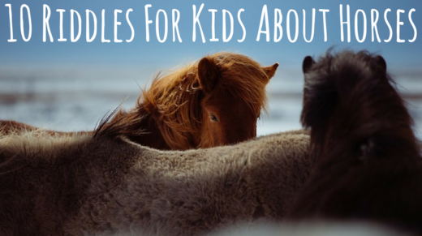
I am a type of animal
Some say that I have a long face
I’m very good at running fast
So people ride me in a race
~
A stallion’s a male
A female is called a mare
You can ride on one of these
On a carousel at a fair
~
On the head and neck of these creatures
You will see that they have quite long manes
It’s best not to hold on to those though
Instead you should hold on to their reins
~
I am a tall animal
I run with a lot of force
I also canter or trot
You can ride me – I’m a _ _ _ _ _
~
When you startle one of these
Off it gallops like a shot
Once this animal’s slowed down
It will then canter or trot
~
You might sometimes see this animal
With a jockey riding on its back
Trying to run as fast as it can
While going round and round a track
~
Before there were cars and trains
This was how people got around
They’d get up on a saddle
Take its reins and then hooves would pound
~
I might be found on a farm
But I’m not known as swine
I run round in a field
And I’m known as equine
~
If you live next door to this animal, it’ll hopefully be a good neigh-bor
~
What Am I?
I have four legs but I’m not a dog
I can run fast but I’m not a cheetah
I like carrots but I’m not a rabbit
I have a mane but I’m not a lion
I can be ridden but I’m not a motorcycle

Shark Riddles
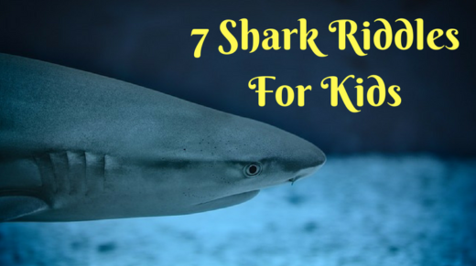
Some people are scared of this creature
Because it can have a big bite
So be careful out in the ocean
One of its kind is a Great White
~
When someone doesn’t swim in the ocean
Then this animal might be the cause
Because they’re afraid they’ll be bitten
By this large fish who’s the star of Jaws
~
I have a very big bite
But I do not ever bark
I swim out in the ocean
I have a fin – I’m a _ _ _ _ _
~
Swimming around the ocean
While prey it does seek
The Discovery Channel
Gives it its own week
~
If you see this in the ocean
Then you will probably pause
Because most people are so scared
Of this creature that’s in Jaws
~
Many people are scared of this fish that has large Jaws
~
What Am I?
I have a lot of teeth but I’m not a cog
I scare a lot of people but I’m not a spider
I have a fin but I’m not a boat
I’m found in the ocean but I’m not a buoy
I sometimes have a hammerhead but I don’t hit nails
http://babelnet.sbg.ac.at/themepark/services/food/riddles-meat.htm

