1. What are the most important innovations for you in your daily life? Think about the following areas.
- communication
- transport
- home entertainment
- food
- other
What innovations would you most like to see in the areas above?
2. The nouns below are often used when talking about innovation. Check that you know the meanings of the words and phrases in the box and complete the extract from the talk below.

drawing board | prototype | brainwave patent concept
discovery | setback | R&D (research and development)
breakthrough | pioneers

The idea of a lone inventor who makes …… or has a sudden clever idea or…is maybe a little out of date today. While these types of…do still exist, these days companies often have large…departments teamsof people who are constantly innovatingand perfecting designs. Perhaps they begin with a ⁵ and then
build a ⁶ or working model. Sometimes during testing there is a
⁷ when it becomes clear the design has a fault. At this point
maybe it is time to start again or go back to the ⁸. More work is
done and there is a ⁹ - a solution is found. The product can be
retested and then, hopefully, manufactured. The company will apply for a
¹⁰ for the design so that others cannot copy it and steal the idea.
3.he adjectives below can be used to describe inventions or new ideas. Which have a positive meaning? Which have a negative meaning? Write + or - next to each one.

brilliant | beneficial | silly | life-saving
pointless | ridiculous | time-saving | annoying
wasteful | life-changing | practical | money-saving
revolutionary | space-saving | ground-breaking
Q Look at the following list of twentieth-century innovations. In your opinion, which is:
- the most important? • the most controversial?
- the most useful? • the most unpopular?

Use words from Exercise to describe the innovations. What other innovations would you add to the list?

1900 | the escalator
1901 | the vacuum cleaner
1923 | the traffic signal
1950 | the heart pacemaker
1956 | TV remote control
1973 | cars with airbags
1974 | the Post-it note
1979 | personal stereo
1986 | laptop computer
1987 | disposable contact lenses
1994 | GM (genetically-modified) tomatoes
1997 | Dolly the sheep (The first mammal cloned from an adult cell.)

Innovation at Procter and Gamble

Do you know which of the following products Procter and Gamble manufactures ?
- cars
- • shampoo
- furniture
- • toothpaste
- washing powder
- anti-ageing cream
- Read the first three paragraphs of the article and answer these questions
1. How is Procter and Gamble better than its competitors in terms of innovation?
2. How has Procter and Gamble benefited from organic growth?
3. Which companies are having problems innovating?
Which of these statements is true?
4. Over 66 percent of senior executives think innovation is very import;
5. More than 50 percent of senior executives are pleased with the return their investment in innovation.
Read the rest of the article. Choose the correct heading for steps 1 to 6 from the list below.
One of the consumer research.
• Reach outside for ideas.
Stop testing so much.
• Give designers more power.
Know what not to do
• Get employees to exchange ideas
Inside Procter and Gamble's innovation machine

A. G. Lafley, the CEO of Procter and Gamble, has brought a lot of creativity and rigor to P&G's innovation process. During the past 2 years, P&G has raised its new-product hit
5 rate (the percentage of new entries that deliver a return above the cost of capital) from 70% to 90%. That's terrific in an industry where half of new products fail within 12 months, according to market
10 research firm Information Resources. 'In the 18 years that I've followed Procter,' says Deutsche Bank analyst Andrew Shore, 'I have never seen the company this good' Organic growth - meaning growth from core 15 businesses, excluding gains from acquisitions - is at the root of P&G's transformation. According to Lafley, organic growth strengthens a company's ability to innovate.
20 Coke, Kraft and Unilever are just a few of the giants that are struggling to innovate and build the brands they already have. According to a recent Boston Consulting Group survey of senior executives, more than two-thirds
25 say innovation is a priority, but 57% are dissatisfied with the returns on their innovation investments.
Lafley has a model for innovating in a big
company: ,
Procter and Gamble has 7,500 R&D people located in nine countries. In order to collect
45 feedback over this vast area, the company encourages employees (both scientists and marketers) to post problems on an internal website. Lafley evaluates the ideas that have been shared between employees. Each year
50 he presents his findings in half-day 'innovation reviews' for each business unit.

Lafley says that his goal is to get half of P&G's invention from external sources, up from 20% four years ago and about 35% 55 today. Inventors are evenly distributed in the population, and we're as likely to find invention in a garage as in our labs,' he explains.

It's not the P&G way to put out a product 60 without test-marketing it. But consumer testing takes time - a luxury that P&G executives increasingly don't have. Says Susan Arnold, P&G's beauty queen: 'We don't have time to cross all the T's and dot all
65 the I's. This business is trend-basec fashion-based. You have to be intuitiv cutting down on test-marketing (but not, you, on science), P & G has reduced pr launch time from laboratory to roll-oul
70 three years to eighteen months com wide.

Lafley believes that P&G needs to marl* just the product itself but the consu experience of the product - how it I
75 smells and feels. Three years ago he i a head of design at P&G, a company vi named Claudia Kotchka, who reports d to him. Her designers used to lab( anonymity on logos and packaging. Bu
80 are now deeply involved in all aspe product development. For Olay Regei they helped with the formulation an fragrance too.

In an attempt to encourage growth, 85 companies offer fat bonuses for innova hire stars from outside. Lafley hasn't either of those things. He doesn't n« revamp pay schemes, he says, notin managers who fail to share ideas sim 90 not get promoted. He does motivate th and file by giving out modest rewards as giving 50 stock options, for creative and by celebrating innovators on internal website.
From Fortune Magazine Q
Find words or phrases in the article which mean the following:
- recruitment of an experienced person
- additional payments for innovation
- customer habits
- the company's intranet
- laboratories
- shorter time for introducing products
The sentences below describe stages in the launch of a new drug. Use the verbs in the box to complete the sentences. Then put the stages in a more logical order.

develop | test | publish |  | test | grant
train | approve | carry out | apply for

1. The drug…. on animals
2. The drug.. in the labs. 3.The results of the trials
4.Market research….
5.The drug... on humans.
6.The trials by the Ethics committee.
7. A licence… .
8.Approval…..by the authorities.
9.The drug representatives.

Use the notes below to describe stages in the launch or a new car.
Use words like first, next, then and finally.

1designer-choose 8 new model-test-specialroads
- design - produce 9 deal with problems-costly if
- model-build problems serious
- modifications-make 10 journalists-invite-test- drive model
- R & D department and engineers n reviews-write-by journalists-
- design - modify major newspapers and car magazine
- prototype - build 12 model-display-famous motor
- new engine-use-or existing exhibition - Geneva or London Mot( engine develop - can be very costly Show

Q Comment on the following statements. In your opinion are they:
a) essential b) helpful c) unhelpful for a successful presentation?
- Tell a joke at the beginning to relax the atmosphere.
- Speak more slowly than you normally do.
- Smile a lot.
- Involve the audience.
- Invite questions during the presentation.
- Always keep to your plan.
- Move around during your presentation.
- Use gestures to emphasise important points.
- Read out your presentation from a script.
10 Stand up when giving your presentation.
What other useful techniques do you know for giving a presentation?

Useful language
Introducing yourself
Good morning, everyone.
Hello everyone, welcome to ...
Structuring the presentation
I'm going to divide my talk into four parts.
First, I'll give you .... After that ,... Finally,....
Inviting questions
If you have any questions, don't hesitate to ask.
I'll be glad to answer any questions (at the end of my talk).
Giving background information
I'll give you some background.
Let's start with the background.

Referring to the audience's knowledge
As you know,...
As you are aware,...
Changing the topic
Right, let's move on to ...
OK, I'll now look at...
Referring to visuals
If you look at the graph ...
Could I draw your attention to the chart?
Concluding
to sum up,...
to summarise,...
Ending
Thanks very much. Any questions?
Well, that's all I have to say.
Thank you for listening.

Topic | Audience | Suggestions
A country you have visited on holiday or done business in | A group of people who will shortly be working there | • way of life  • transport  • accommodation  • food and drink  • standard of living | • customs and traditions  • weather  • language  • people  • entertainment
Your company's main competitors | The board of directors of your company | • identifying the competition  • their strengths and weaknesses  • how powerful they are in the market
Your job | A group of high school students at a careers evening | • responsibilities and tasks  • the future  • perks and special advantages, e.g. foreign travel  • qualifications  • career structure

Комунальний заклад освіти ””Середня загальноосвітня школа №42 ”
”Освіта і творчість”
Інтерактивні форми навчання
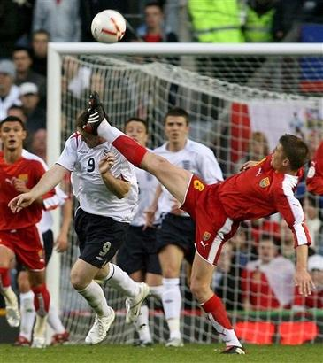
на уроках англійської мови

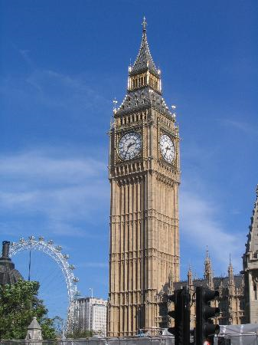




Дніпропетровськ 2010

